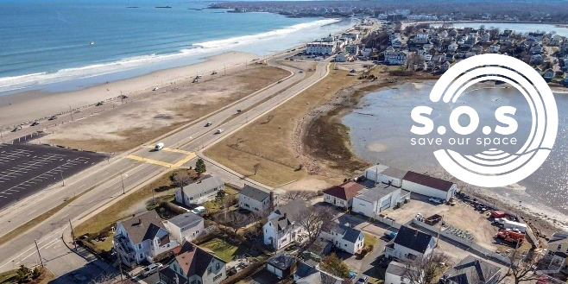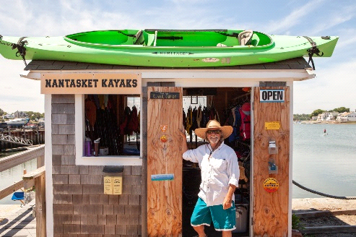

**JOIN US FOR A SPECIAL SUNSET KAYAK TOUR**

**OF THE WEIR RIVER ESTUARY**

**An educational outing to benefit SOSHull**

**Date: Friday June 14, 2024, 5:45 PM – 7:45 PM**

***Space is limited to 30. Register today.*****(Rain/Wind Date: Friday, June 28, 2024)**

*After the kayak tour, we will be joined by* ***Samantha Woods****, Executive Director of the North and South Rivers Watershed Association, and Board Member, Weir River Watershed Association. Learn more about the Weir River estuary, its’ wildlife and protecting this fragile and important marine resource. Meet up for this special gathering at The Drift (formerly Red Sky). Immediately following the paddle.*

***Many thanks to our friends at Steamboat Wharf Marina for providing appetizers for the social hour and remarks after the paddle.***

**Cost:** $50/person can be made via credit card, check or cash upon arrival on the day of event.

**Registration required by emailing**: [Kayakflower@gmail.com](mailto:Kayakflower@gmail.com) or calling Judy (781)-367-0626.

**Questions:** Contact SOS Activities Committee @ [SOShullactivity@gmail.com](mailto:SOShullactivity@gmail.com), or Maggie (617)-306-2764.

**Meet at:**  Nantasket Kayaks, 48 George Washington Blvd, Hull, next to The Drift (formerly RedSky) in Hull.

**Parking: DO NOT PARK IN FRONT OF NANTASKET KAYAKS**. FREE PARKING IS AVAILABLE DIRECTLY ON STEAMBOAT WHARF MARINA’S FAR END TOWARD THEIR GUEST DOCK. Please carpool, bike, get dropped off, or park at the DCR Lot across the way.

**Kayak Tour:** Scott Plympton, owner of **Nantasket Kayaks**, will provide a tour of the Weir River Estuary pointing out its flora, fauna, and special protections under the Area of Critical Environmental Concern (ACEC) designation. [**https://nantasketkayaks.com/**](https://nantasketkayaks.com/)

**SOS (Save our Space) Hull:** A citizens action group focused on the (HRA) Hull Redevelopment Authority land. Proceeds from this event will help bring vision, awareness, and advocacy together in support of preserving the beauty, character and sustainability of the largest remaining open land in Hull, (area between Phipps and Water St. in Hull). Learn more at: [www.soshull.org](http://www.soshull.org)